In the Delfi-C3 spacecraft, the Electrical Power Subsystem (EPS) is responsible for generating electrical power and supplying it to the various loads in an appropriate form.
Power generation is accomplished by using four solar arrays. Every array consists of a single string of 5 TEC1 triple junction gallium arsenide (GaAs) cells in series, which are provided by Dutch Space. A high performance can be assured as the efficiency of the cells rises to 23% in test conditions. However, the magnitude of actual produced power is dependent on cell temperature and the level of incident radiation. Therefore, in nominal operations every array is at an offset angle of 35 degrees with the body to ensure sufficient power production at every attitude.

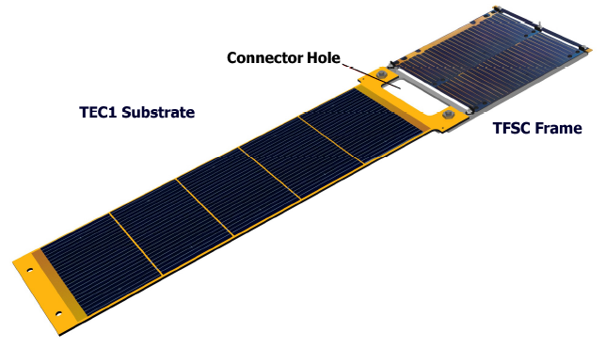

One of the most striking characteristics of the Delfi-C3 spacecraft is the absence of any battery or supercapacitor. As no power storage is present, all required power at a particular instance has to be generated by the solar cells. Therefore, the Delfi-C3 spacecraft will not be operational in eclipse. During sunset the spacecraft will shut down due to an inability to maintain the required bus voltage, and during sunset the computer will commence a new boot sequence for powering up the spacecraft.
As the electrical characteristics of the solar arrays are dependent on temperature and level of incident radiation, power conditioning is applied to produce a stable bus voltage. Step-up converters are used for generating 12V on the bus. Every individual solar array is equipped with its own converter to ensure redundancy in the system. The DC/DC converters make use of negative feedback to ensure that the output voltage is stable at 12V independent of the input voltage of the converters as this value can change heavily. In order to suppress ripples in the bus voltage every converter is equipped with a low-pass filter at its output.
With respect to power conditioning, no specific provisions are made. This means that only the required electrical power is removed from the solar array, with the remaining power staying at the array. As the minimum required power is far less than the maximum generated power, the operating point of the solar cells will move along a large part of the IV-curve of the solar cells.
Because every individual load aboard the spacecraft makes use of a characteristic input voltage, the bus voltage is converted down to the needed voltage locally. The following voltages are used on board the Delfi-C3 spacecraft:
- 3V3
- 5V
- -1V25
- 12V
In order to waste as little power as possible, high efficiency step-down converters are applied, which are able to yield efficiencies of approximately 85%.
Power supply to the individual printed circuit boards is controlled by a local microcontroller. This microcontroller is able to switch solid-state switches (i.e. MOSFETs) on and off when it receives a command from the onboard computer. If commands from the onboard computer are not able to arrive at the microcontroller, the microcontroller will go to degraded mode (OBM mode). In OBM mode, the microcontroller makes use of a timer to decide whether the printed circuit board should be supplied with power. In case the MOSFETs are switched on, the local step-down DC/DC converters are supplied with power and in turn will supply the PCB electronics with power.

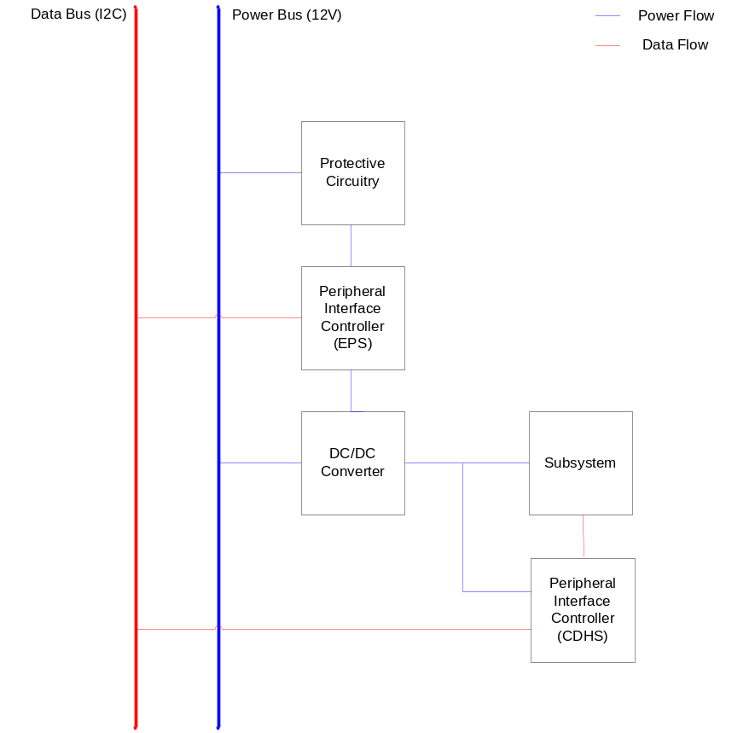

However, the onboard computer, the receivers on the communications boards and the local EPS microcontrollers cannot be switched off. Therefore, these pieces of equipment are always supplied with power in case the bus voltage is at its nominal value of 12V.

